SOFTWARE REQUIREMENT

SPECIFICATION(SRS)

FOR

COVID-19

**INTRODUCTION:**

Objective:

Building an User Interface and User Experience to track the spread of covid-19 virus.

Users of the System:

1.   Government

2.   Public

Functional Requirements:

* To build an application that Public can access and view the status about the spread of COVID19.
* The application should have signup, login, profile, dashboard page and individual records.

1.Rate of covid spread in each state

2. Confirmed Cases

3. Deaths

4. Fatality Rate

5.Recovery Rate

6. Latest Update

7.Regions which are under lockdown

8.No of people who got vaccinated in each state

* This application should have filters like Low to High or showcasing COVID19 affected area
* It should have a provision to maintain a database for individual , public information and COVID19 documents.
* Aadhar integration for intimating individual reports to the public.
* Clarified that all contact tracing and COVID-19 status apps, including ones that

merely store an individual’s vaccination or test records, need to complete theCOVID-19 contact tracing and status apps, section in the App content page.

* Apps that provide medical, treatment, vaccine, testing, or other related

information for COVID-19.

* Apps that support services for COVID-19, such as,the

apps that providesocial services( food stamps, payment), healthcare, loans, etc.,

OUTPUT/ POST CONDITION:

* Records Persisted in Success and Failure Collections
* Standalone application / Deployed in an app Container

NON-FUNCTIONAL REQUIREMENTS:

* Security:
* The app stores moderately sensitive data about its users and hence a certain level of security is expected
* App review and visibilityApps must handle all personal or sensitive user data securely.
* Apps must have a publicly accessible privacy policy that comprehensively discloses the access, collection, use and sharing of personal and sensitive user data.
* STANDARD FEATURES:
* Number of individuals tested
* Confirmed cases
* Deaths in the country
* Red zones where the positive cases are very high
* Locations of public testing centers in each state
* Updates from the World Health Organisation(WHO)
* LOGIN:

 The system should support logging(app/web/DB) at all levels

* CLOUD:

 The Solution should be made Cloud-ready and should have a minimum impact when moving away to Cloud infrastructure

* BROWSERS COMPATIBLE:

All latest browsers

Application assumptions:

1.   The login page should be the first page rendered when the application loads.

2.   Unless logged into the system, the user cannot navigate to any other pages.

3.   Logging out must again redirect to the login page.

4.   To navigate to the admin side, you can store a user type as admin in the

database with a username and password as admin.

5.   Use admin/admin as the username and password to navigate to the admin

dashboard.

Validations:

* Aadhar Password validations should be performed
* Basic mobile validation should be performed.

Project Tasks:

* Complete the COVID-19 contact tracing and status apps, section in the App content page
* Submit proof of eligibility via the Advance Notice form
* Privacy requirements
* App visibility and user awareness
* For apps that collect information when running as a background service
* Editorial and quality requirements
* App review and visibility

USER:

Covid 19 heat map

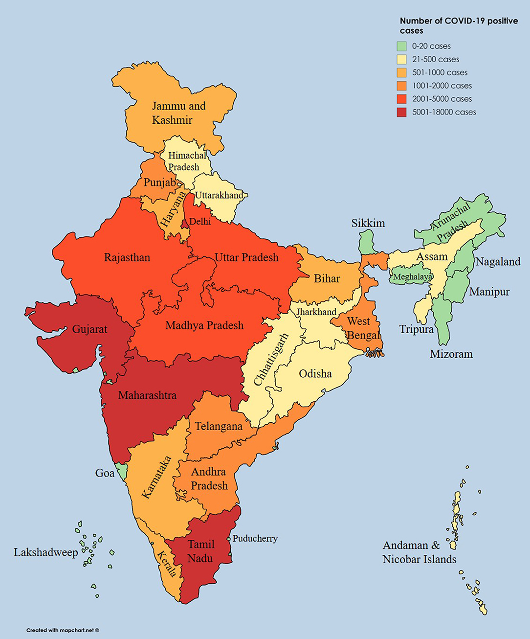

FRONTEND:

CUSTOMER:

1. Authentication:

Design an auth component .Once the component is created in react app, name the jsx file as same as component name where the customer can authenticate login and signup credentials

1. Signup:

Design a signup page component . Once the component is created in react app, name the jsx file as same as component name where the new customer has options to sign up by providing their basic details.

* Ids:
* Aadhar number
* mobilenumber
* password
* confirm password
* Submit Button
* signinLink
* signupBox

1. Login:

Design a login page component .

Once the component is created in react app, name the jsx file as same as component name, where the

existing customer can log in using the registered email id and password.

* Ids:
* Aadhar number
* password
* submitButton
* signupLink
* loginBox

1. Dashboard / Home:

Design a home page component. Once the component is created in react app, name the jsx file as same as component name that has the navigation bar

* Ids:
* userNavigation bar
* HomeButton
* Personnel data
* Over all State data
* LogoutButton

5.Admin:

* Admin Dashboard:

Design a dashboard page.Once the numbers created in react app, name the jsx file as same as component name.

* Admin navigation:

Design a navigation component.

* Ids:
* Admin navigation bar
* Admin add button
* Admin confirm button
* Logout button
* Add number of patients affected:

Design an add product component

* addnumber of affected count
* StateName
* District Name
* Aadhar Number
* affected
* Recovered
* adddataButton
* Screen Shot:

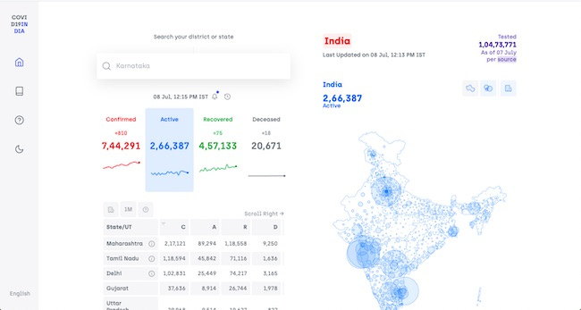

BACKEND:

Class and Method description:

* Model Layer:

1.UserModal:

This class stores the user type (admin or the customer) and all user

information.

* Attributes:

                            i.   Aadhar: String

                           ii.   password: String

                          iii.   mobileNumber: String

                          iv.   active: Boolean

                           v.   role: String

2. LoginModel:

This class contains the email and password of the user.

* Attributes:

                             i.   Aadhar: String

                            ii.   password: String

3. Covid 19 Model:

This class stores the details of the patient.

* Attributes:

1. State Id: String
2. patient name: String
3. Status : String

THANK YOU!!

SRS DOCUMENT BY

-E.Sasmitha

-J.Pavithra

-Rithika